**Heart disease Project**

Attribute Information:

1. Gender: The individual's gender (Male or Female).
2. Blood Pressure: The individual's blood pressure (systolic).
3. Cholesterol Level: The individual's total cholesterol level.
4. Exercise Habits: The individual's exercise habits (Low, Medium, High).
5. Smoking: Whether the individual smokes or not (Yes or No).
6. Family Heart Disease: Whether there is a family history of heart disease (Yes or No).
7. Diabetes: Whether the individual has diabetes (Yes or No).
8. BMI: The individual's body mass index.
9. High Blood Pressure: Whether the individual has high blood pressure (Yes or No).
10. Low HDL Cholesterol: Whether the individual has low HDL cholesterol (Yes or No).
11. High LDL Cholesterol: Whether the individual has high LDL cholesterol (Yes or No).
12. Alcohol Consumption: The individual's alcohol consumption level (None, Low, Medium, High).
13. Stress Level: The individual's stress level (Low, Medium, High).
14. Sleep Hours: The number of hours the individual sleeps.
15. Sugar Consumption: The individual's sugar consumption level (Low, Medium, High).
16. Triglyceride Level: The individual's triglyceride level.
17. Fasting Blood Sugar: The individual's fasting blood sugar level.
18. CRP Level: The C-reactive protein level (a marker of inflammation).
19. Homocysteine Level: The individual's homocysteine level (an amino acid that affects blood vessel health).
20. Heart Disease Status: The individual's heart disease status (Yes or No).

Data information:

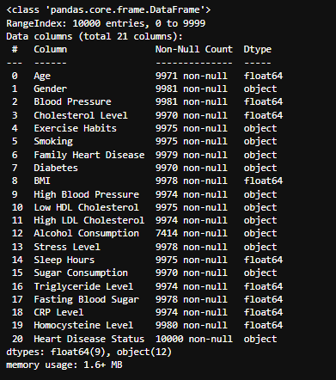

Data overview:

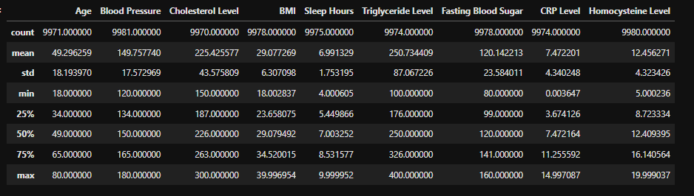

Data null:

